# Power Estimation

In this tutorial we will learn how to estimate the power by using ModelSim to generate the switching activity of the design, and XPower (from Xilinx) to analyze the results and generate the final power report and CosmosScope to visualize the results.

## Different Types of Power

Typically, power dissipation in a cell is subdivided into two different groups, dynamic power, and static power. **Dynamic power** is the power dissipated in a cell when the input voltage is actively transitioning. Dynamic power is further subdivided into two components switching power and internal power. **Switching power** is the power required to charge the capacitive load on the output pins of the cell. Switching power is shown in Figure 7-1, as the Isw switching current charging up the Cload capacitor. This component of power is calculated using the familiar ½ CV2 equation.

For switching power, all we need to know is Vdd and the capacitive load that is driven by the cell. Therefore, the library does not need to be characterized for this component of power dissipation.



Figure 7‑1: Switching Power Dissipation

**Internal power** consists of short-circuit power and power dissipated by charging the capacitive loads that are internal to the cell (not shown in the above circuit). Short-circuit power is the power that is dissipated due to the short period that paths in the cell are essentially short circuits. In the circuit shown above, Iint, that is the current path when the device is short-circuited, shows internal power. Every time the input Vin toggles, there is a short period of time where both transistors are turned on and there is a path from Vdd to ground. The longer both transistors are active, the higher the power dissipation. The circuit above is quite simple (an inverter) and there is only one path from Vdd to ground. For complex circuits, you could have dozens of potential short circuit paths. Internal power is dependent on the transition time of the input voltage Vin and the output capacitive load. These factors determine how long the short circuit is active. There is no easy formula to determine the power dissipated due to internal power, so the cell must be characterized for it.

The final component of power analysis is the **Leakage power**. In the circuit diagram in Figure 7-1, it is shown as leak current. This is the power dissipated when the circuit is in a steady state and it is due to the following factors inherent in transistors: reverse bias leakage current, sub-threshold current, or other second-order leakage power. Leakage power has become a major factor in power analysis in recent era.

At 180 nm and above, leakage power was typically less than 1% of the total power dissipation in a circuit. With 130 nm and below, the leakage power becomes a much larger factor, up to 50% of dissipated power in some cases. Leakage power should be characterized for each cell in the library.

To report the switching power, we need the switching activities of the design. The switching activity contains information about the static probability and toggle rate. The static probability can be calculated during a simulation by comparing the time a signal is at a certain logic state (state 0 or state 1) to the total time of simulation. The toggle rate is the number of transitions between logic-0 and logic-1 (or vice versa) of a design object per unit of time.

The previous power definitions can be concluded by these two equations:

Total Power = Dynamic power + Leakage power

Dynamic Power = Switching power + Internal power

## Estimating the Power Consumption

To estimate the power consumption for a specific application on a specific CPU you need to generate the switching activities, which are saved as a Value Change Dump (VCD) file. This file is generated when the project is simulated using ModelSim and the application is executed on the CPU. Then the VCD file will be used as input to the XPower tool, which finally will generate the power report. This report can be visualized using the CosmosScope visualization tool.

### Generate the VCD file using ModelSim

The VCD (Value Change Dump) file can be generated during the ModelSim simulation to capture signals switching activities as explained below:

1. Create a ModelSim project in your project’s ModelSim directory, add your CPU VHDL files from your project’s “meister/*.syn” directory, and add testbench files from the ModelSim directory, as explained in the Chapter. Remember that you should already have generated TestData.IM and TestData.DM files in your ModelSim directory using “make sim”.
2. Configure the CPU Frequency for which you want to run the power estimation. Open the ModelSim testbench (tb_browstd32.vhd), search for CLK_PERIOD, and change the value accordingly. Take care: For simulation-reasons this value corresponds to the time (in nanoseconds) of a half clock period. For example, 10 ns half period correspond to 20 ns clock period, which is 50 MHz frequency.
3. Compile the project Compile 🡪 Compile Order 🡪 Auto Generate
4. Start the simulation: VSIM > **vsim -t 1ns work.cfg**
5. Store the switching activities during the program execution in the VCD file e.g. “test.vcd” by typing: VSIM > **vcd file test.vcd**
6. Add all signals of the CPU instance: VSIM > **vcd add -r test/dut/\***
7. The entity name of the tutorial example testbench is test and the instance name of the device under test is dut. Using the -r switch with ModelSim “vcd add” command will result in a large but significantly more accurate VCD file. VCD files can grow quite large for larger designs or even for smaller designs if the simulation time is long.
8. Run the simulation: VSIM > **run -all**
9. The switching activities will be saved in “test.vcd” file.

### Generating the Power Report Using xPower

The second step is to create an ISE project that you want to analyze for power consumption. Create a new project and add only the CPU files from the ASIP Meister “meister/xxx.syn” directory to it. In the “Processes”-tree of your top-level design and under “Implement Design/Place & Route”, click on “Analyze Power Distribution (xPower Analyzer)”. This will open the xPower window. Now, click on “File>open Design”, in the “Design” file, you have to add your .ncd file e.g. toplevel.ncd” and in “Simulation Activity” file, you have to add the .vcd file that you generated in the previous step. Finally, in the “Physical Constraint” file, you can add the .pcf file for you project e.g. “toplevel.pcf” as shown in Figure 7-2. As soon as you click OK, the XPower tool will analyze the files and gives you a summary about the power consumption in your design (like the Leakage power and the total power). On the right side, you find “By Clock Domain”. Here you see the frequency in (MHz). The clock frequency should be the same frequency that you used in testbench during VCD file generated as shown in Figure 7-3.

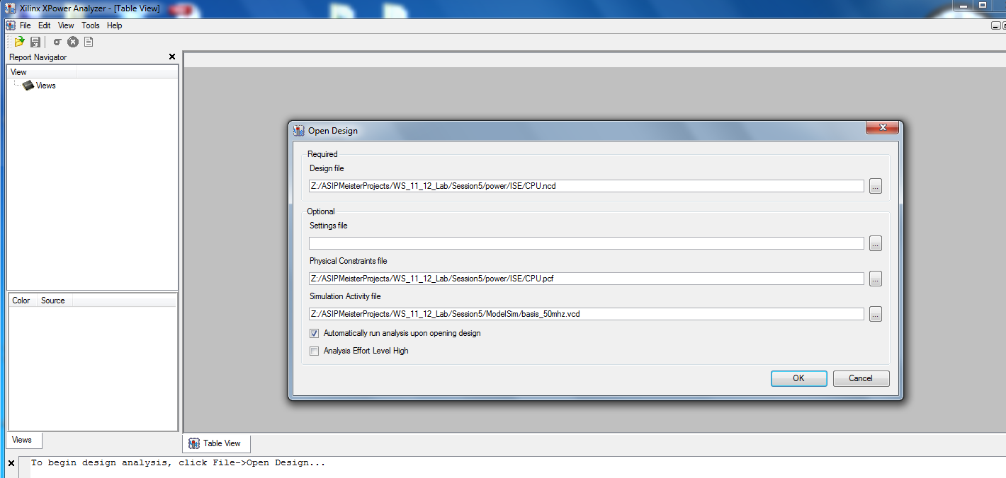

Figure 7‑2: Preparing xPower Tool

***Important Note:***

It is worthy to know that the total power number that you get from xPower is the Dynamic power plus the Leakage power. When you read the leakage power consumption, you will see that is much higher than the dynamic power. This is because the leakage power is total leakage power consumed in the whole FPGA chip even if your design is small and it occupies a very small part of the chip. Since Vitrex5 does not have a power gating, the leakage power is always consumed and high.

For that, when you take the power number for your design, you have to consider only the dynamic power in order to make your results comparable and see clearly how much you have to pay for your custom instructions in terms of power.

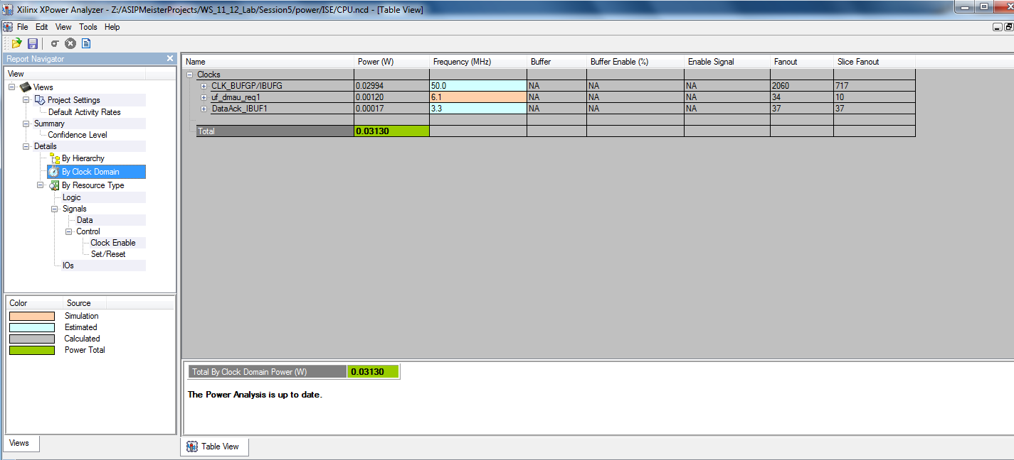

Figure 7‑3: Checking the CPU Frequency

To compare the power consumption between two processors, the average value will not give correct information because every processor can execute the same application with different execution time, as shown in Figure 7-3. In this case, we need to consider the energy. The energy is defined as the power consumed during whole execution time, and given as:

🡺 E = P * T



Figure 7‑4: Power Dissipation as Average Value



Figure 7‑5: Energy Comparison between two Processors